Shields Up /Have I Been Pwned?

**Question 1: What Did You Do?**

**GRC (Shields Up) Vulnerability Scan:** The first part of this assignment required me to visit <https://www.grc.com/x/ne.dll?bh0bkyd2> and run a vulnerability scan on my computer. I then scanned the common ports, followed by ports 0-1055. The purpose of the vulnerability scan was to ping the ports of my computer.

**Have I Been Pwned?:** The second part of this assignment required me to visit <https://haveibeenpwned.com/> to determine if my email or password had been breached. I, first, entered my email to determine if any breaches had occurred. Next, I entered one of my passwords to see if that had been breached. My email/ password was checked against databases that have been associated with breached information.

**Question 2: What Were the Results?**

**GRC (Shields Up) Vulnerability Scan:** According to the GRC Port Authority Report there were a total of 26 common ports tested. The report also show that 0 ports were open, 11 ports were closed, and 15 ports were stealth. The report, for ports 0-1055, showed 0 ports open, 73 closed, and 983 ports were stealth.

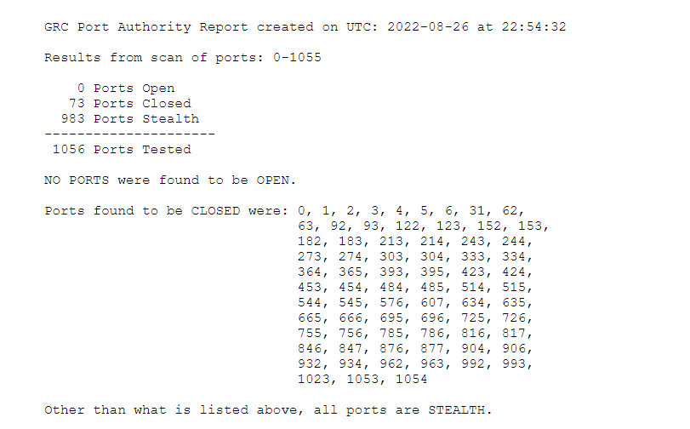

**Have I Been Pwned?:** The results from the email displayed “  
Good news – no pwnage found!” I was quite happy to see this result. The result for the password also showed “Good news – no pwnage found!

**Question 3: What Did You Learn?**

I would say that I learned a few things from these exercises as well as from Dr. Jennex’s lectures. I learned that most of my ports were closed or in stealth. I know this is important because hackers often employ “port sniffing” for open ports. I also learned, from the “Why Computers are Vulnerable” lecture, that computers about 65,000 ports. I honestly had no idea computers had that many ports. I was happy to learn that my password and email had not been breached. I also learned the importance of having a strong “pass phrase” as opposed to a strong password. I intend to utilize the “pass phrase” approach to cyber security.